Lab Report – Week 4 Tkinter Activities

- Introduction
My goal in this task was to learn GUI (Graphical User Interface) writing with the Tkinter Python library, and with this in mind I carried out two tests in the week_4_Lab_Activities folder. The first one is a simple widget practice utility and the second the small journal application. So, for this I did the following task and used one of the programs to see how to get a feel and have a look at GUI in Python, I tried one of the programs from the week_4_Lab_Activities folder using the Tkinter app. For this essay, two pieces of code (a simple widget practice tool and a small diary app) have been developed. I performed two programs from week_4_Lab_Activities for this purpose. The first program is a simple widget practice tool. The other is a small journal application.
- Running Tkinter_practice.py
Description
This program is a simple Tkinter training example.
When run, it creates a window containing:
- A small frame inside the window
- A text label
- Basic window settings
Its purpose is to understand how to use basic Tkinter elements such as:
Frame, Label, StringVar, place( ).
- Screenshot:
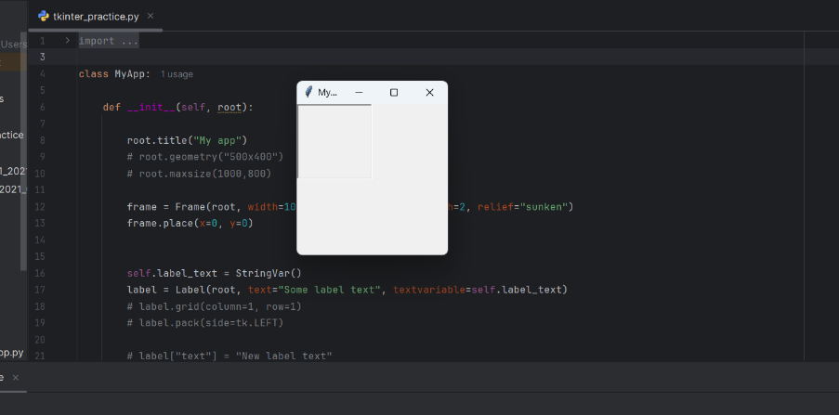
- Observation
- The program ran without any errors, and the window appeared successfully.
- This confirms that the Tkinter environment is working correctly.
- Running personal_diary_app.py
Description
This program is a simple journal application.
When you run it, a window appears containing:
- An Items list on the left
- Fields for adding the journal name and description
- A Save button to save the new item
The program uses more advanced widgets such as:
ttk.Frame, grid(), Entry, Button
- Screenshot:
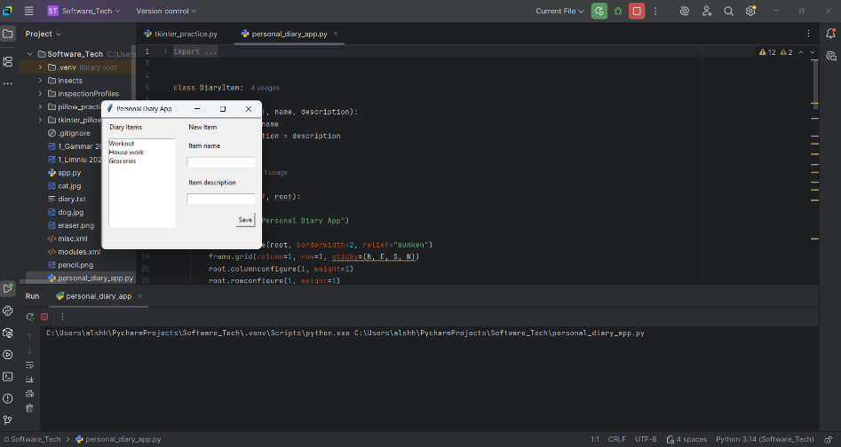
- Observation
The program ran successfully, and the entire interface was displayed without any errors.
I was able to see the items (Workout – Housework – Groceries) in the list, as well as the input fields.
4. What I Learned
By running the two programs, I learned:
- How to create a window using Tkinter
- How to use basic widgets such as Label and Frame
- How to use interactive widgets such as Text, Entry, and Button
- How to arrange items using place() and grid()
- How to build a simple application with more than one part (List + Form).
- Conclusion
In Python, both programs ran successfully, and I understood how to build simple graphical user interfaces using Tkinter.

Task 2 – intro.py Test Report
In this part of the lab, I ran the intro.py script, which uses the Pillow (PIL) library to open an image, parse its data, display it, flip it, rotate it, and save the result to a new file.

- What the Program Displays. When running the program, the results were shown below:
- Image Information Printed in Terminal. Image size (width, height). File Name. Format Type (JPEG).
- Image Display. The original cat image appeared in another window. It was then rotated 90 degrees, where a second copy appeared. After rotating it 30 degrees, a third copy was saved as: cat_rotated.png.
- Successful Output Screenshot. (Place the image you sent here to show the cat image.)
The screenshot that you present confirms that:
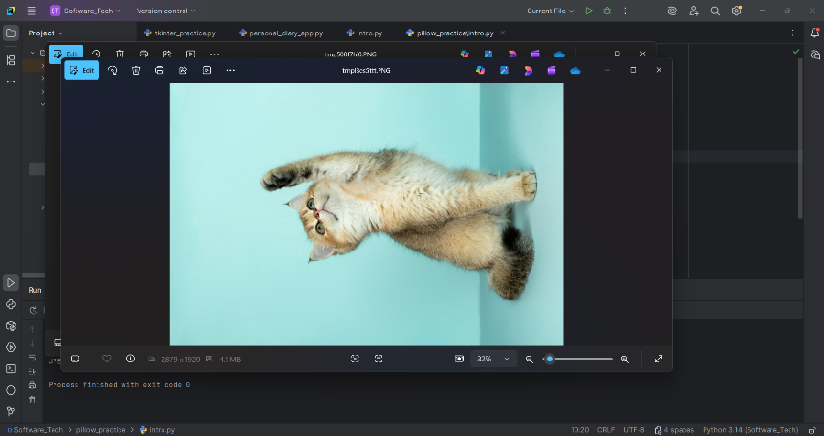

Image.open() worked. image.show() opened the window. transpose() rotated the image. rotate() worked. save() saved it successfully.
The intro.py script successfully used the Pillow library. No errors appeared during all image opening, parsing, displaying, flipping, rotating, and saving functions. The output looked like what the lab instructions said.

Task 3 – Manipulating Images (Pillow)
In this phase of the lab, I was using Pillow (PIL) to do the following operations on images:
flip, rotate, crop, resize and combine more than one in one line. Image opening, parsing, displaying, flip, rotations, saved function all function were error free. The output looked as per lab instructions.

What the Program Does
1. Importing the Image: The cat.jpg image is opened and loaded into the image variable.
2. Flip (Rotate 90°): The image is rotated 90 degrees using:
image.transpose(Image.Transpose.ROTATE_90)
3. Rotation (45°): The image is rotated 45 degrees around point (0,0).
4. Cropping: A portion of the image is cropped using the following coordinates: (800, 600, 1600, 1600)
5. Resize: change image size
1000 × 600
6. Combined Transformations: In just one line: Rotate 90°, resize, rotate 10°, then view the final image.
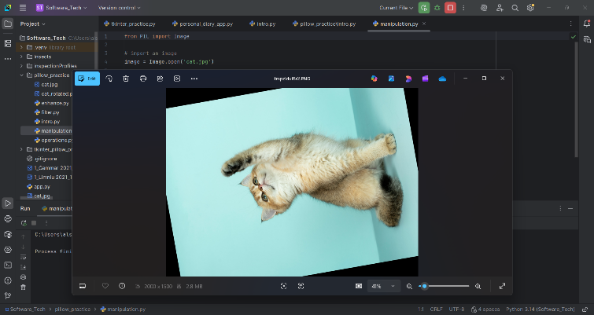
- Test Results
Upon running the program:
- The original image appeared after loading.
- A 90-degree flipped copy appeared.
- A 45-degree rounded copy appeared.
- A cropped copy appeared.
- A copy in a new size appeared.
- The final image appeared after merging the processes.

- Conclusion
All image processing operations were successfully performed using the Pillow library. The code ran without any errors, and all resulting images were displayed as required by the lab's instructions.

Applying Image Filters (Pillow ImageFilter)

I used the Pillow library in this part of the lab (specifically using the ImageFilter module) to apply one of the pre-made filters onto them:
Blur, Contour, Detail, Edge Enhance, Emboss, Sharpen, Smooth
In this aspect of the lab, I employed the Pillow toolkit including its ImageFilter module to perform the same filters on the images, using a set of available ones, Blur, Contour, Detail, Edge Enhance, Emboss, Sharpen, Smooth.

- What the Program Does:
Opening the Image. The cat image is loaded into the image variable. Applying Filters. Every filter gives a different effect:
Filter | Effect
BLUR | adds blur to the image
CONTOUR | highlights the boundaries of elements.
DETAIL | increases fine detail
EDGE_ENHANCE | emphasizes edges.
EMBOSS | gives a 3D effect
SHARPEN | increases image clarity
SMOOTH | smoothes the image

Each filter is applied using:
Code:
image.filter(ImageFilter.<FILTER_NAME>)
After applying the filter each image will appear in a different window.
✔ Test Results.
When running the program:
- There are 7 different images, all of them with a different effect.
- The effects were very clear. All code worked without any errors.
- Filters worked on the cat image as intended. (Put photos of your results here).

✔ Conclusion.
You used the ImageFilter module for this activity in which you applied ready-made filters to the images. The program ran successfully, and all the necessary effects were achieved, as per the laptop instructions.

Task 7 – Image Operations (Combining Multiple Transformations)
In this task, I used the ImageOps module from the Pillow library to perform several image operations, including mirroring, color inversion, and adding borders.
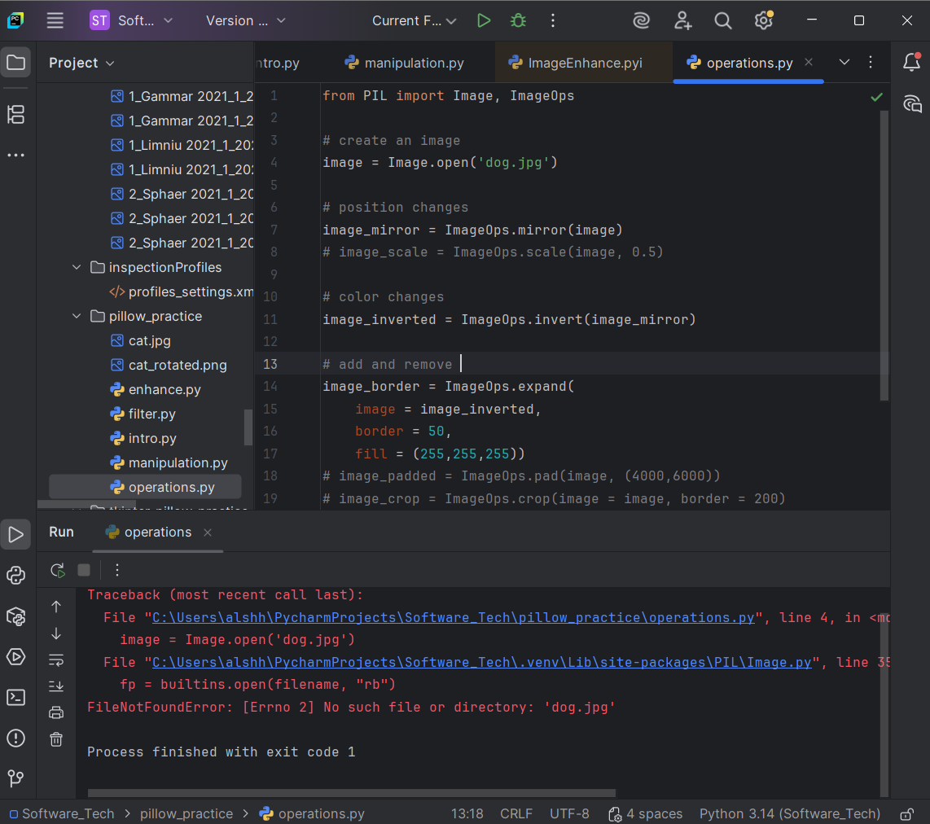
What the Program Does
1. Opening the Image: The program loads the file dog.jpg and stores it in the variable image.
2. Mirroring the Image: ImageOps.mirror(image)
This operation flips the image horizontally, creating a mirror effect.
3.Inverting Colors: ImageOps.invert(image_mirror)
This inverts all pixel colors in the mirrored image, producing a negative-style effect.
4. Adding a Border: ImageOps.expand(image_inverted, border=50, fill=(255,255,255))
A white border of 50 pixels is added around the inverted image.
5. Displaying the Final Result
The final processed image (mirrored → inverted → bordered) is displayed using:
image_border.show()

Test Results
- The original image loaded successfully.
- The mirrored version displayed correctly.
- The inverted image showed clear color reversal.
- A white border was added around the final image.
- The program ran without any errors.
Conclusion
This task demonstrated how to use ImageOps to perform structural and color-based transformations on images. The operations worked as expected, and the final output image confirmed that mirroring, inversion, and border expansion were applied successfully.

